**Final Lab Project – Tone Control/Karaoke Circuit**

Hongyi Lai

12/12/2020

EE 210 Section 1

Sujay Hosur

# Introduction

This project is designing a Tone Control/Karaoke Circuit with five blocks, Mixer/Karaoke, Tone Control, Volume Control, Volume Display, Attenuator and Output Driver.

# Design and Simulation

## Block 1

### Design Objective

This block accepts two unbalanced input signals and outputs a single inverted and amplified mono output signal. The circuit must be designed so that the two unbalanced inputs each contribute the same amount to the output signal. Depending on the position of a SPDT selector switch, we can change to Mixer or Karaoke application of the circuit.

### Schematic

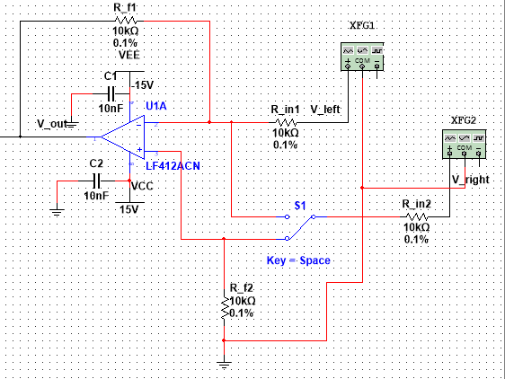

### Theory of Operation

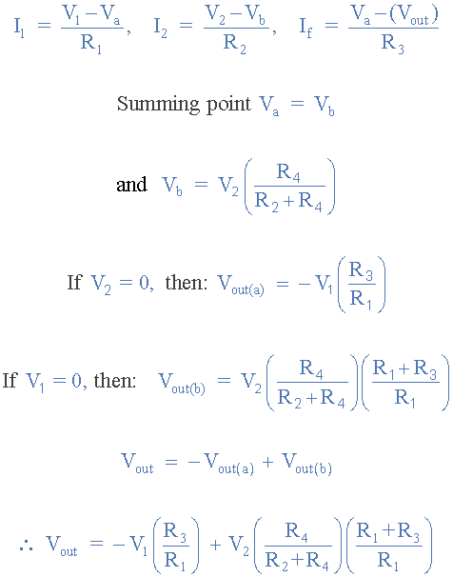The circuit is based on the canonical inverting summing amplifier, with a gain equation given by   
. The values for R2 and R3 are determined with respect to R1 and with respect to the amplitudes of Vright and Vleft. For the differential amplifier,

### Derivations/Calculations

In order to maintain the voltage of the circuit,

We can calculate via formular above.

So, we can get Rf = R1 = R2 = 10k

### Simulation Results

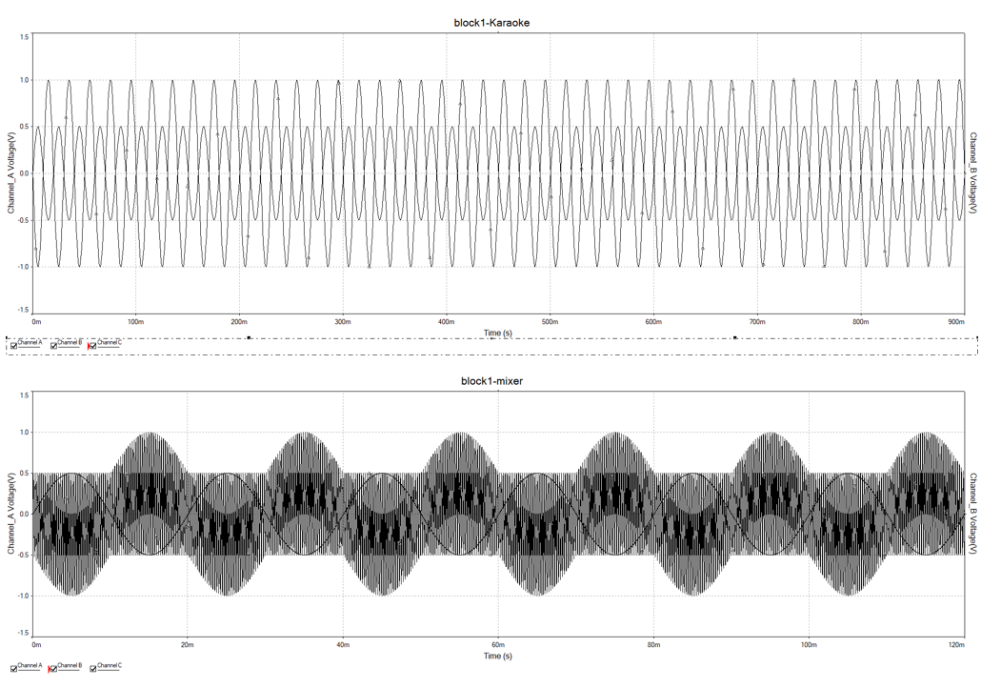

## Block 2

### Design Objective

This block would serve as a tone control filter. Depending on the position of the pin of the potentiometer, which is a 100 kΩ potentiometers and select the external resistors (labeled R1 and R2 in the circuit diagrams) to get a gain range of approximately 1/10 to 10 for both bass and treble.

### Schematic

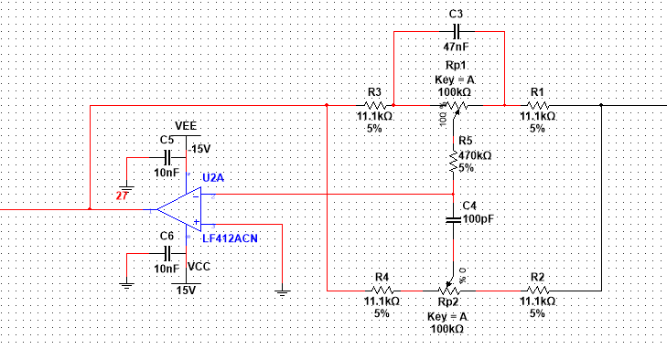

### Theory of Operation

- Circuit's operation is since capacitors act like open circuits at low frequencies and short circuits at high frequencies. Be-cause- C1 << C2, it has a higher impedance for any given frequency, so it continues to act like an” open circuit" for higher frequencies than C2does.

For low input signal frequencies, both capacitors act like open circuits, so the bottom potentiometer setting has no effect on the circuit because the middle terminal is connected to an open circuit.

For middle input signal frequencies, the top capacitor (C2) acts like a short circuit and the- bottom capacitor(C1} still acts like an open circuit, so neither potentiometer setting has any effect on the circuit.

For high Input signal frequencies, both capacitors act like shott circuits, so the- top potentiometer has no effect on the circuit, but the bottom potentiometer is now connected.

The values of the two capacitors and the valves of the resistors determine the boundaries between what is considered "low frequency" and what is considered "high frequency". For audio applications, where frequencies, range from 20 Hz to 20000 Hz, the boundary is usually chosen to be- In the 400-1000 Hz range.

### Derivations/Calculations

10 = -R2 / R2 + Rp

10 = R2/R2 + 100k

R2 = 11.1k

So, R1 = R2 = R3 = R4 = 11.1k

### Simulation Results

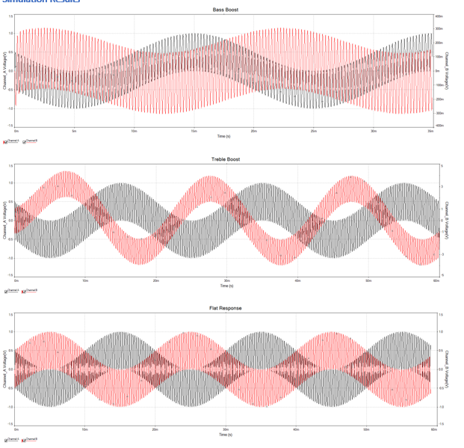

## Block 3

### Design Objective

This block of circuit would be able to adjust the output by turning the pin of the potentiometer. The output would be from 0% to 100% of the input.

### Schematic

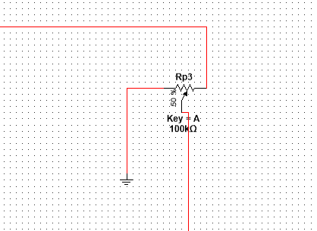

### Theory of Operation

A potentiometer is a good tool when variable voltage is wanted. Since the desired output was from 0% to 100% if the input, simply connecting the potentiometer in series with input source and measuring the absolute voltage of the pin would fulfill the goal.

### Derivations/Calculations

## Block 4

### Design Objective

The purpose of this experiment is to use op-amps in comparator mode, along with light-emitting diodes (LEDs), to create a simple voltage level meter.

This block of circuit would serve as a voltage meter with 4 LED indicators. Each LED would light up in sequence as the input voltage increased. When the input just passed 0.25Vpp, the bottom LED would first light up. The second bottom LED would light up after the input passed 0.5Vpp, third is 1V and fourth is 1.25V.

### Schematic

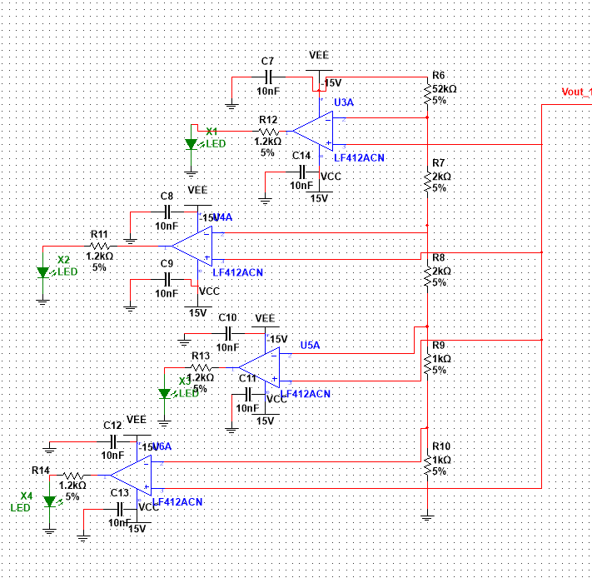

### Theory of Operation

This block of circuit would serve as a voltage meter with 4 LED indicators. Each LED would light up in sequence as the input voltage increased. When the input just passed 0.25Vpp, the bottom LED would first light up. The second bottom LED would light up after the input passed 0.5Vpp, third is 1V and fourth is 1.25V.

### Derivations/Calculations

base on the solve the equation, for voltage division,

the ratio for R1-R5 is 52:2:2: 1:1

however, I do not have enough resistor, I replace

2.2k->2k

47k->52k

## Block 5

### Design Objective

The input to this block is the output of the volume-control block. This block is an inverting op amp with gain set to make sure that the maximum output voltage level stays in an appropriate range (0.5 – 1V maximum amplitude) for driving headphones.

### Schematic

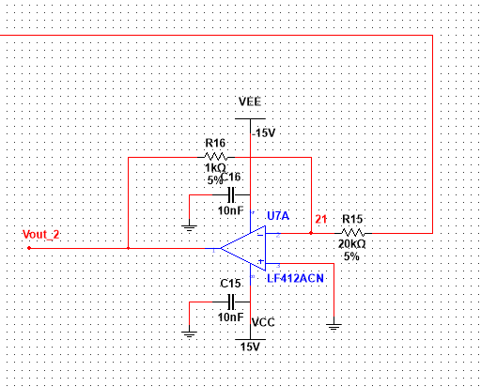

### Theory of Operation

Taking into account the maximum gains that Block 1 and Block 2 can yield,

### Derivations/Calculations

### Simulation Results

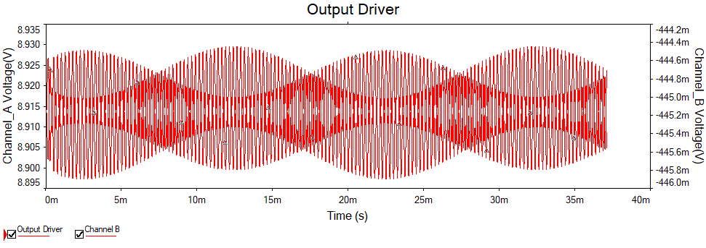

# Complete Assembly

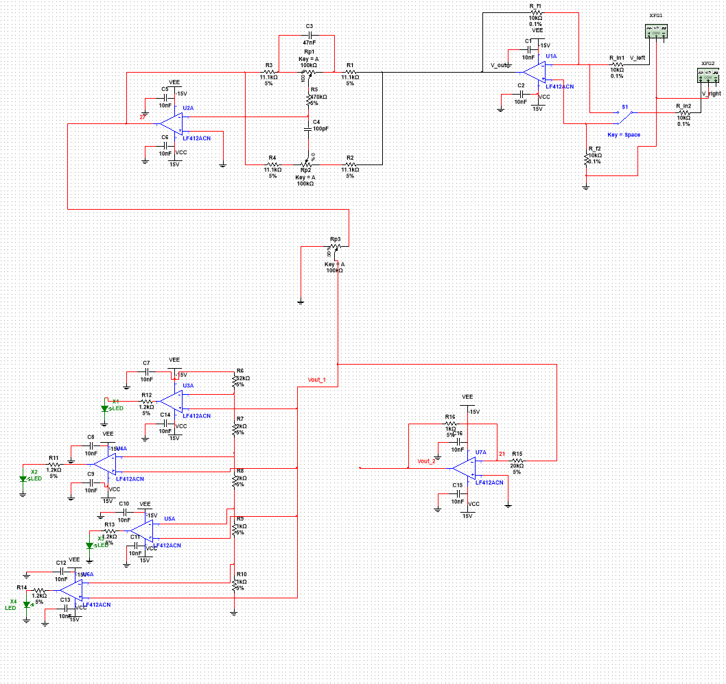

# PCB Layout

PCB Silkscreen Layer

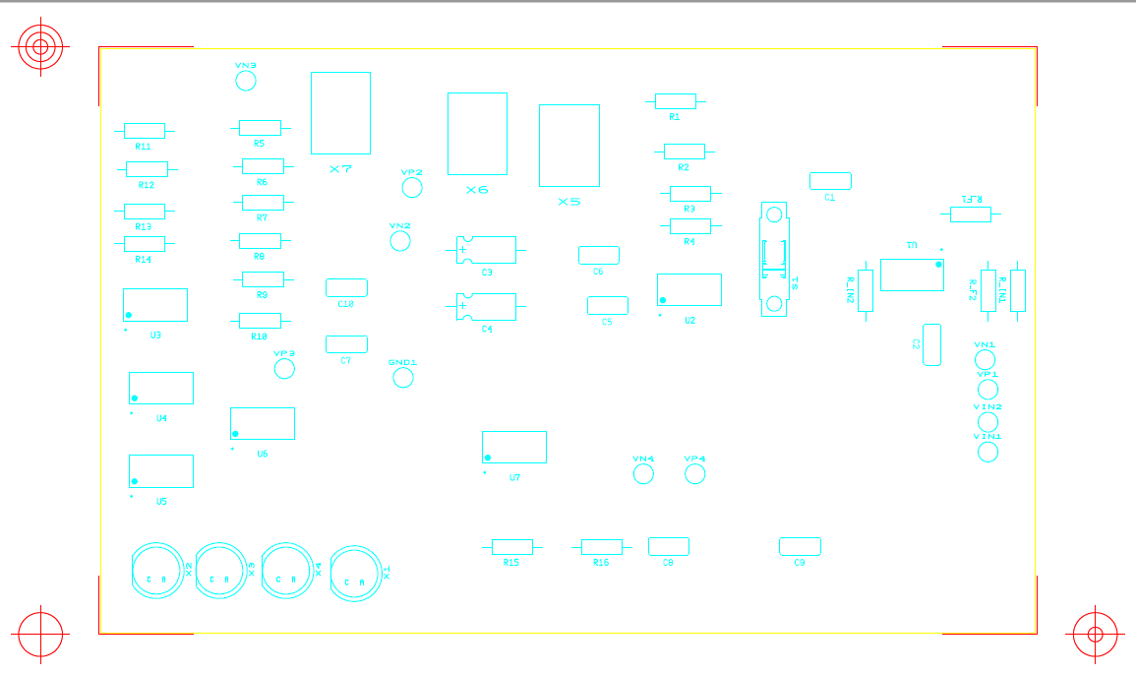

Copper Top Layer

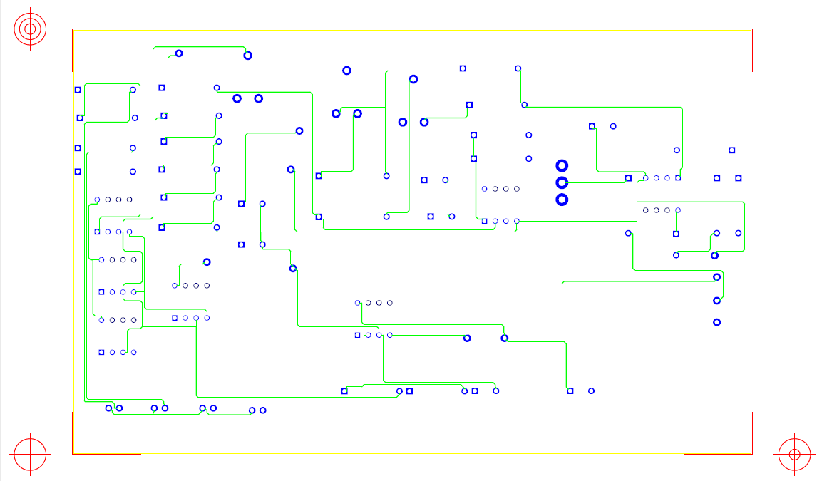

Copper Bottom Layer

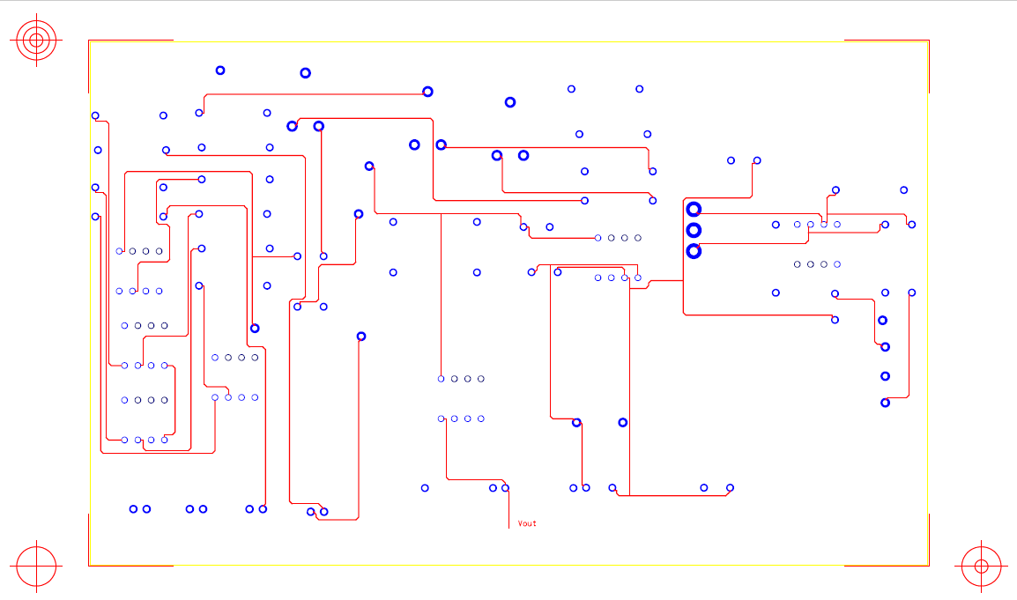

Superimposed

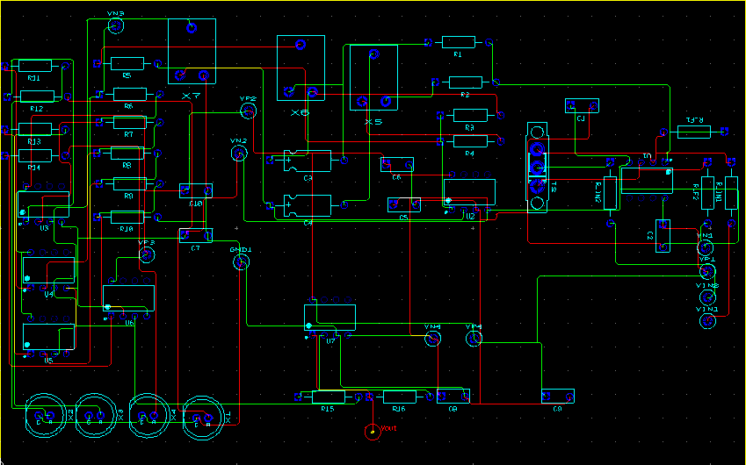

# Breadboard Images

Overall

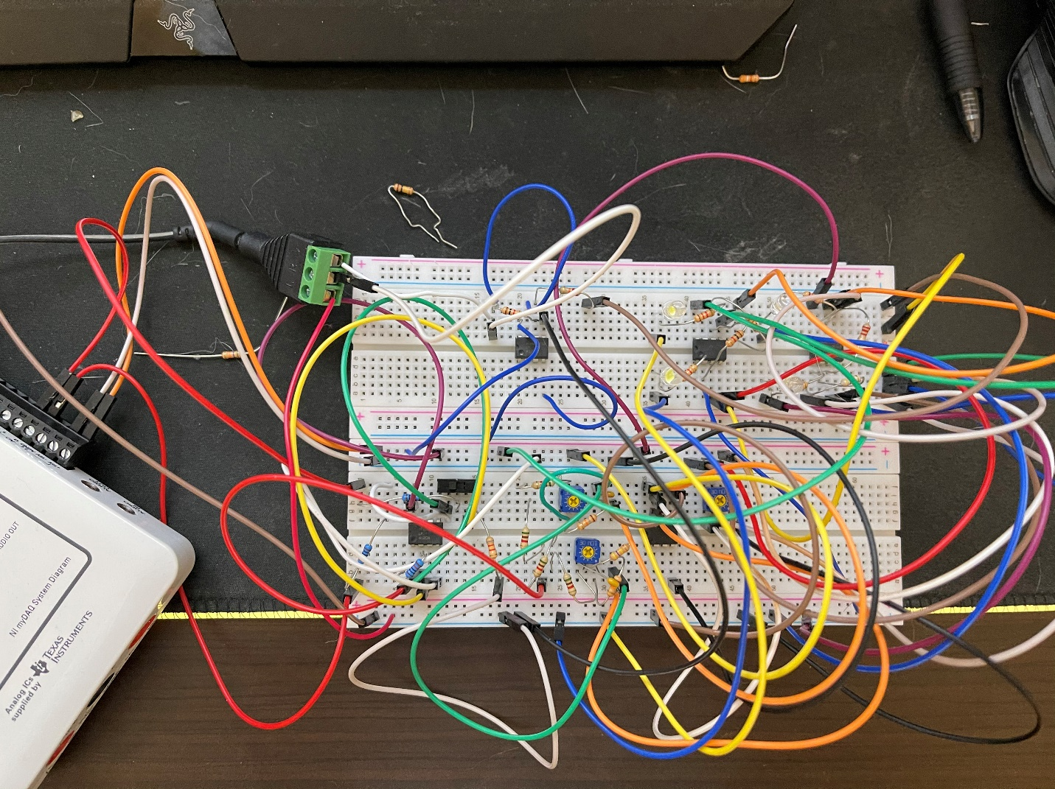

Block 1, 2, 3

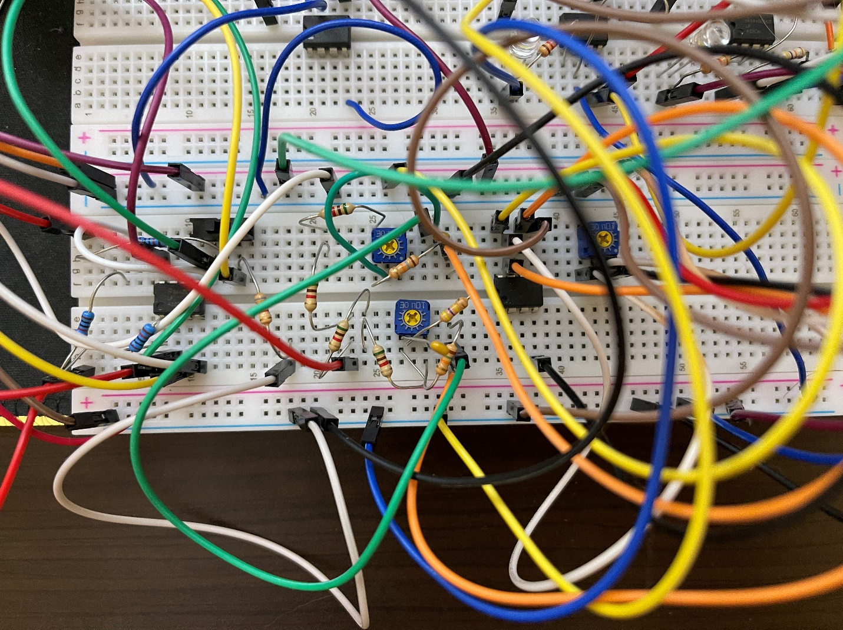

Block 4, 5

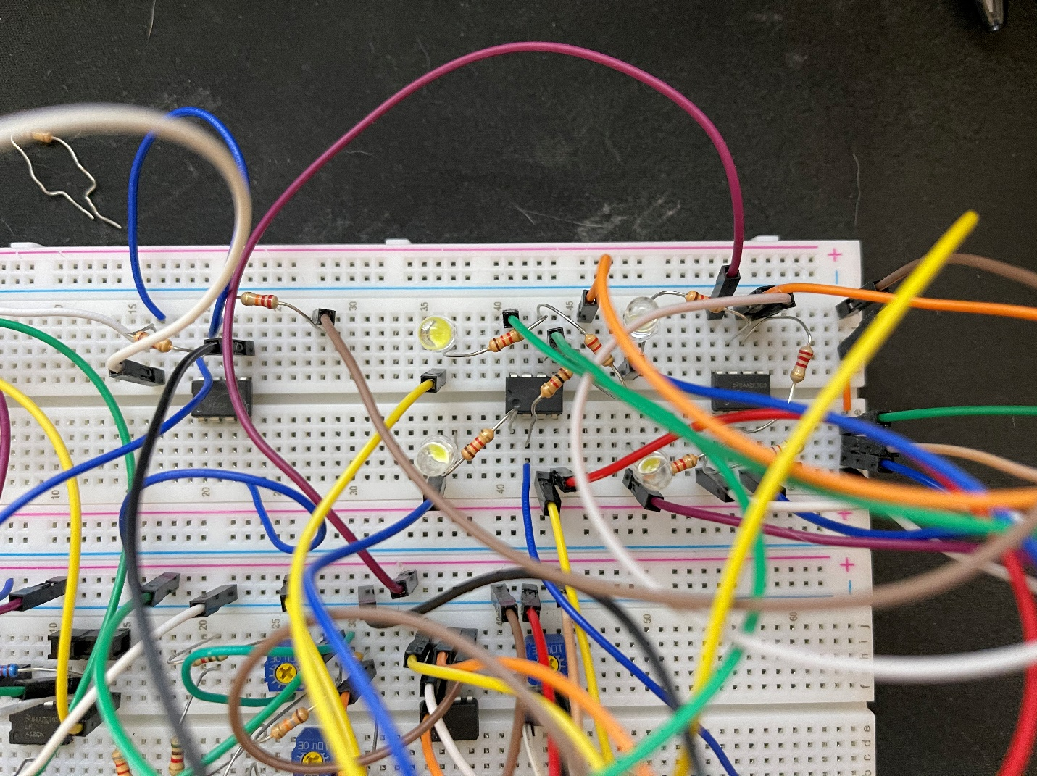

# Conclusion

This is my first electrical or engineering project in college. So, of course, I have faced lots of problem, like how to make the connection between the knowledge we learned in the school and put the knowledge in the breadboard or PCB. At the beginning of the project, I do not understand the propose of this circuit, and did not know how to get started. Lucky, my TA helps a lot! He helps me make the connection between the theory and practice, and make sure the value of the resistor. Also, I have a major problem in putting the circuit I designed in multisim into the ultiboard. There are so many elements I need I need replace, because some of the element in the multisim can’t not be shown in ultiboard. And I spend few hours to solve this problem. Thanks to this project, I will spend more time in designing and learning electrical circuit in the future, yes, it does have lots of fun!